

**WEB SERVICES TECHNOLOGY**

**Design and implement Hospital Management System Rest APIs**

**Part 1**

Name: Salem Hammad – 1181737

Dr. Mohammad Kharmah

Identify 4 core resources required by Hospital Management System:

1. **Laboratory Test:** Represents various laboratory tests that can be performed at the hospital. It includes details like test name, description, associated costs, and any specific requirements.
2. **Medical Staff:** Represents the non-doctor medical staff members working at the hospital, such as nurses, technicians, and pharmacists. It includes their contact details, job roles, and shifts.
3. **Ward/Room:** Represents the physical spaces where patients are accommodated during their hospital stay. It includes attributes like ward/room number, capacity, availability, and associated staff.
4. **Electronic Health Records (EHR):** Represents the digital records of patients' medical history, diagnoses, treatments, and other relevant information. It includes attributes like patient demographics, allergies, lab results, and prescribed medications.

1. Laboratory Test:

Class Name: LaboratoryTest

Attributes: testId, testName, description, cost, requirements

Operations: getTestId(), getTestName(), getDescription(), getCost(), getRequirements(), performTest()

Medical Staff:

1. MedicalStaff

Class Name: MedicalStaff

Attributes: staffId, name, contactDetails, shift

Operations: getStaffId(), getName(), getContactDetails(), getJobRole(), getShift(), assignToWard()

Ward/Room:

1. WardRoom

Class Name: WardRoom

Attributes: roomNumber, capacity, availability, associatedStaff

Operations: getRoomNumber(), getCapacity(), checkAvailability(), assignStaff()

1. Electronic Health Records (EHR):

Class Name: ElectronicHealthRecord

Attributes: patientId, patientName, demographics, allergies, medicalHistory, prescriptions

Operations: getPatientId(), getPatientName(), getDemographics(), getAllergies(), getMedicalHistory(), getPrescriptions(), updateRecord()

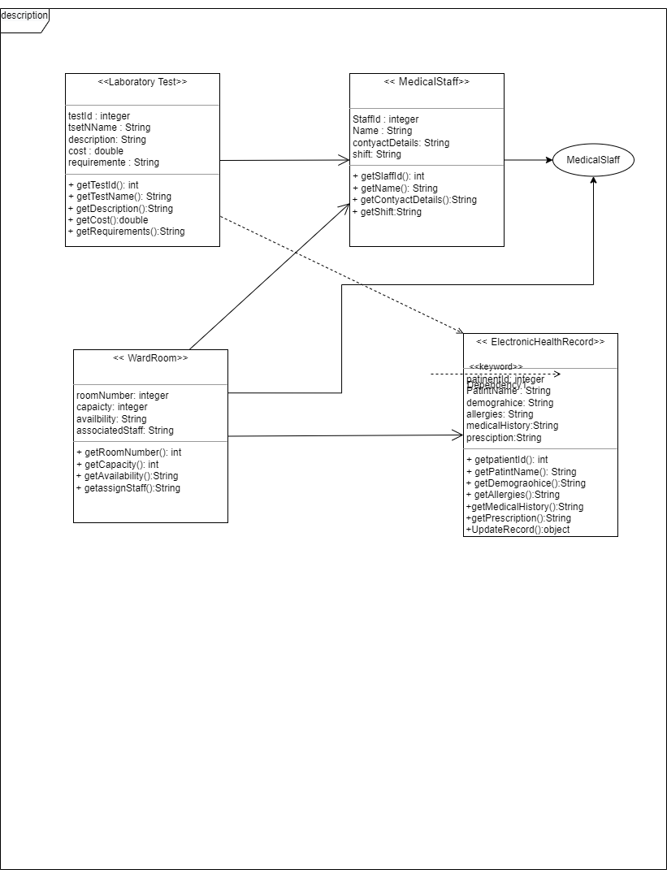

**Electronic Health Record Module**

|  |  |  |  |  |  |
| --- | --- | --- | --- | --- | --- |
| HTTP Method | URL path | HTTP state code | Description | Sample Requst | Sample Respons |
| POST | <http://localhost:8081/>  **Electronic Health Record** | 200 | Add  **Electronic Health Record** | {      "patientName":"taha",      "demographics":"test2",      "allergies":"2test",      "medicalHistory":"22.22.2202",      "prescription":"prescription"  } |  |
| GET | <http://localhost:8081/>  **Electronic Health Record** | 200 | GET ALL nurse | - | [      {          "patientId": 1,          "patientName": "taha",          "demographics": "test2",          "allergies": "2test",          "medicalHistory": "22.22.2202",          "prescription": "prescription"      }  ] |
| PUT | <http://localhost:8081/>  **Electronic Health Record** /1 | 200 | Update value | http://localhost:8081/electronicHealthRecordController/1?patientName=ali | [      {          "patientId": 1,          "patientName": "ali",          "demographics": **null**,          "allergies": **null**,          "medicalHistory": **null**,          "prescription": **null**      }  ] |
| DELET | <http://localhost:8081/>  **Electronic Health Record**/2 | 200 | Delete | -http://localhost:8081/electronicHealthRecordController/2 | -[      {          "patientId": 1,          "patientName": "ali",          "demographics": **null**,          "allergies": **null**,          "medicalHistory": **null**,          "prescription": **null**      }  ] |